Assembling the kit. Programming

LOTI.05.010 Robotics

Spring semester 2015/16

Practice session 2
The aim of this practice session is to get familiar with the GoPiGo robot platform and basic programming.

Assembling the kit
When assembling the kit, do not use too much force. The plastic is brittle and you may break it.
The instructions can be found here:
http://www.dexterindustries.com/GoPiGo/getting-started-with-your-gopigo-raspberry-pi-robot-kit-2/1-assemble-the-gopigo-2/assemble-gopigo-raspberry-pi-robot/1-assemble-the-gopigo2/
Do not install the canopy (smaller plastic sheet with holes) and the standoffs holding it up.

Instead of eight AA-batteries we will be using a rechargeable 3S LiPo battery.

Sometimes rubber bands on the wheels can improve traction, so if you can also use them if you think this is necessary. If you think you are finished, show the work to instructor.

ATTENTION!! When you connect GoPiGo to battery make sure that the USB power adapter is disconnected. Never use the LiPo battery without a voltage alarm.

Connecting Raspberry Pi
Never connect or disconnect Raspberry Pi from GoPiGo kit when it is powered.

Raspberry Pi connects to the kit upside down. The SD card has to face the battery and USB the LEDs on the GoPiGo board. You can see from the following image how a proper connection will look like. When connecting the long pin header, support the red board with your fingers. If you bend the board to much, you may break something.

Do not connect USB power supply to Raspberry Pi while the external battery is connected.
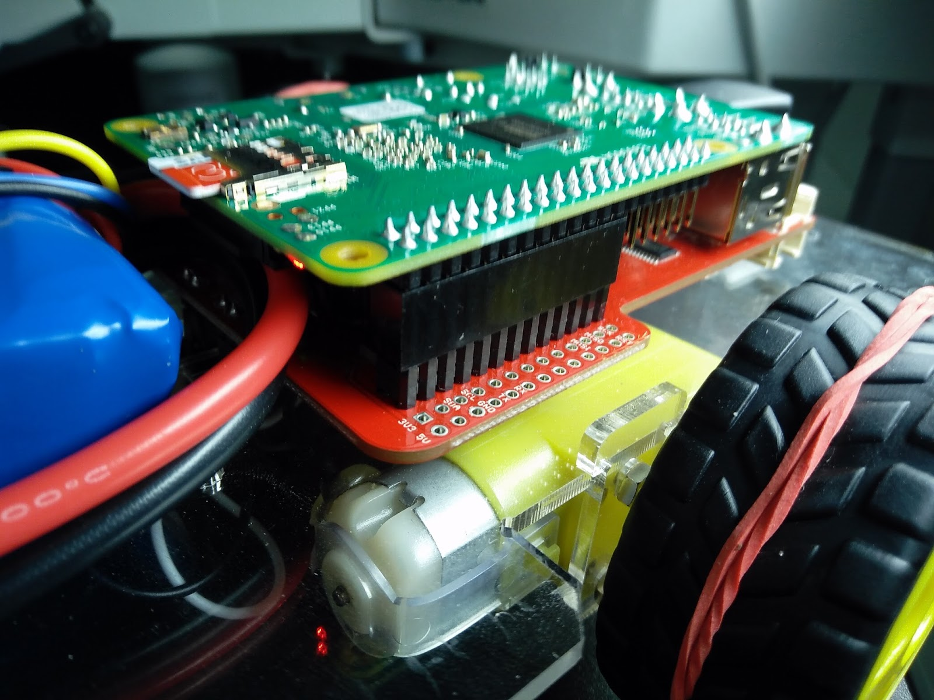

Programming

Python API
This lab will teach you how to program the robot in Python. You can use other languages if you want, but we may not be able to help you, if there are any problem with your code.

Python API documentation can be found here:
http://www.dexterindustries.com/GoPiGo/programming/python-programming-for-the-raspberry-pi-gopigo/

You can find Python 2 in menu under programming. When you click on it, Python shell will open. Here you can enter code line by line and each line will be executed after you press enter. If you want to save and edit your code go to File → New File.

When using commands to move the robot, make sure it is upside down or on the floor. Otherwise you may accidentally drive off the table and break the robot.

Python basics
You need to know following commands in Python to complete this lab.

Sleep
Sleep is used to wait a certain amount of time before executing next command. To use sleep we need module time.
import time
time.sleep(time_in_s)

Loops
To run a command or multiple commands several times for-loop. For example if you want to move and turn three times you can use:
for i in range(3):
fwd()
time.sleep(1)

instead of
fwd()
time.sleep(1)
fwd()
time.sleep(1)
fwd()
time.sleep(1)

Importing modules
You saw in the sleep example line
import time
This tells Python to import functions from module time so you can use them in your code.
If you want to run GoPiGo commands, you must import module gopigo
from gopigo import *

Functions (optional)
You may want to use functions to define some commands. For example you may want a function that moves robot for t seconds and then stops. It looks like this:
def forward(t):
fwd()
time.sleep(t)
stop()
To use the function enter
forward(1)
to move forward for one second.

Additional information
If you need more help, you can look at the tutorial on: http://www.tutorialspoint.com/python/python_basic_syntax.htm

Example
Following program will move the robot forward for one second, turn right for half a second, move back for a second and then stop
from gopigo import *
import time

fwd()
time.sleep(1)
right()
time.sleep(0.5)
bwd()
time.sleep(1)
stop()

Tasks
To learn the API and Python write programs to solve the following tasks
- Move the robot one second forward and one second backwards at 75% speed. Repeat five times. ( CHECK function.py Code)
- Drive in a square. You can choose the length of the side.
- Drive on the black line on the classroom floor. Do this as fast as you can.
  - Turn on the left LED while turning left and the right LED while turning right. Turn on both LEDs while driving forward.(You still need to specify the sides and lengths)

